**Programming Assignment 3**

**Simulator of Google Search**

**Engine Results Page (SERP) using Quick Sort and Red Black Tree**

CS 146 – Intro to Algorithm and Data Structure

Design by Linjun Cao

**Table of Contents**

1. Explain Google Search Engine Simulator design and implementation details --------------------------------- 3
2. Explanation of the Classes/Functions
3. Classes ---------------------------------------- 5
4. Functions --------------------------------------- 19
5. The procedure of how to unzip files, install application, and run/test codes --------------------------------------- 32
6. Problems encountered during the implementation ---- 33
7. Lessons Learned --------------------------------------- 34

**Part I: Explain Google Search Engine Simulator design and implementation details**

Programming-3 is based on Programming-2. So, the part of web crawler will remain the same as the previous one. And the sorting algorithm (Quick Sort) remain the same as well. The only thing that changes is the Binary Search Tree becomes the Red Black Tree.

First, we need to make it clear that which parts need to change. In Binary Search Tree, the node has index, total score, URL and rank. While in Red Black Tree, it must include color. To decide the type of color, I make some try. First, I use type Color. And when I print the tree, I get java.awt.Color[r=255,g=0,b=0] as RED and java.awt.Color[r=0,g=0,b=0] as BLACK. Then I change to string and it is more straight forward. Then I work on function. Search(), In-order-Tree-Walk(), Iterative-Search(), Tree-Minimum(), Tree-Maximum(), Successor(), Transplant(), left-Rotate() and right-Rotate() remain no change. While Insert() and Delete() is quite different from Binary Search Tree. Because the exist of the color, every time the tree is changed, the color of other nodes may change. So, there are also two Fix-up method.

When I build my Red Black Tree, I work step by step. First, I extend from Binary Search Tree class to test if all methods except insertion and deletion are work. Then I work on Insertion and test it in main method. After every case in Insertion works well, then I work on Deletion. I use Divide-and-Conquer.

Part II: 2. Explanation of the Classes/Functions

Classes:

We have the following classes.

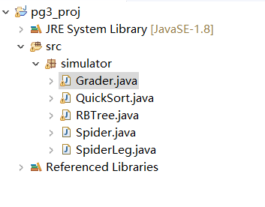

Class Spider and Class SpiderLeg are the part of web crawler. It ‘eats’ a link and a key word and give URLs which we need. An array is created to collect those URLs until it has already got 30 URLs.

Here are some screen shots of these two classes:





Class QuickSort is the part to achieve quicksort. Here are some screen shots of it:



Here is the result of the test:

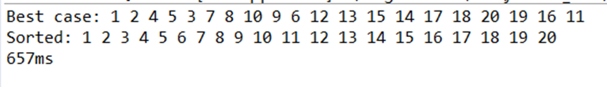

Class RBTree is the part to build Red Black Tree. It included the function both from text book and my customer made.

Here are some screen shots of it:

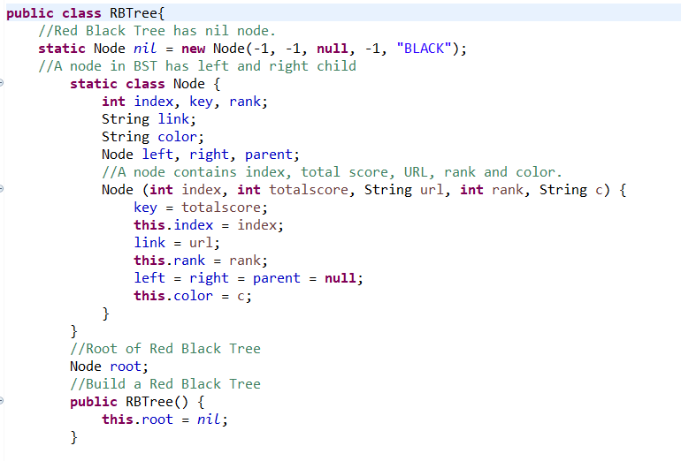

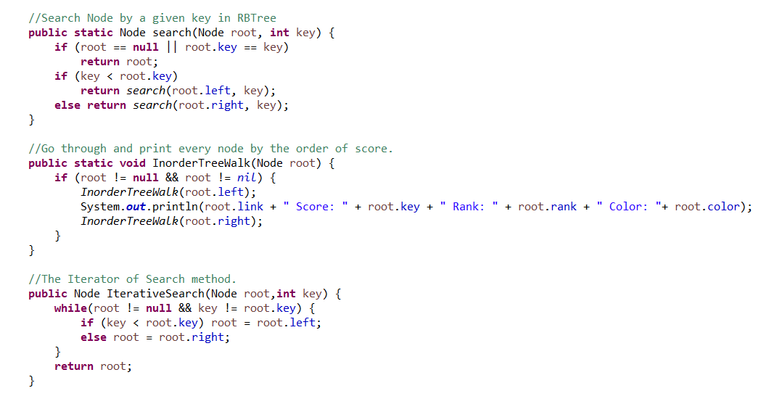

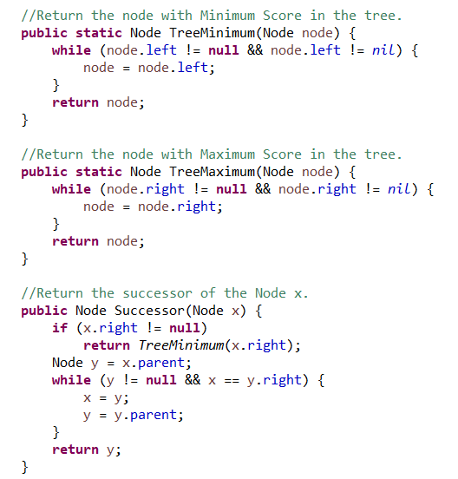

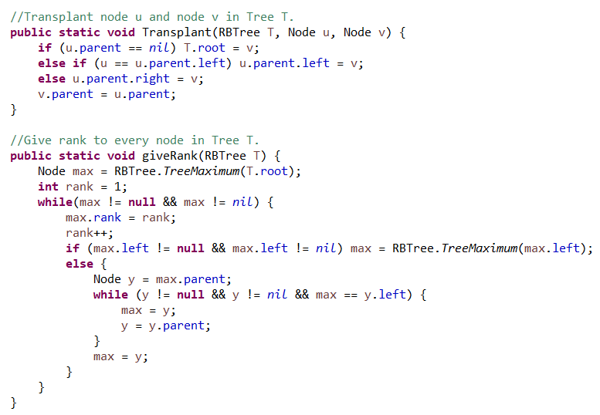

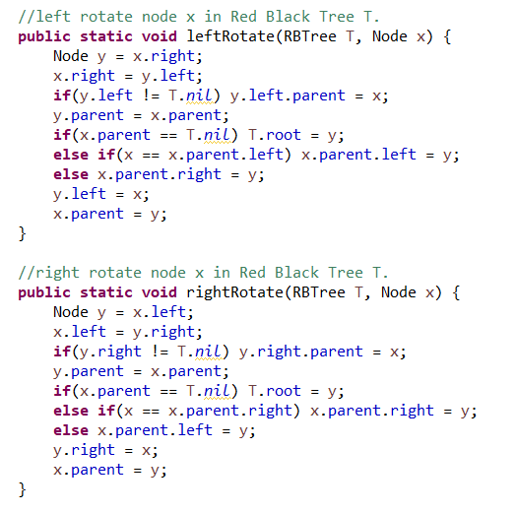

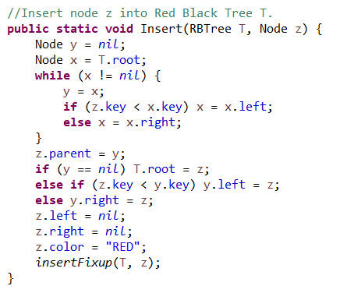

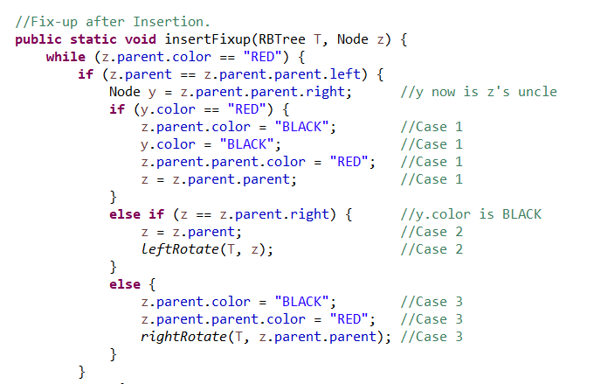

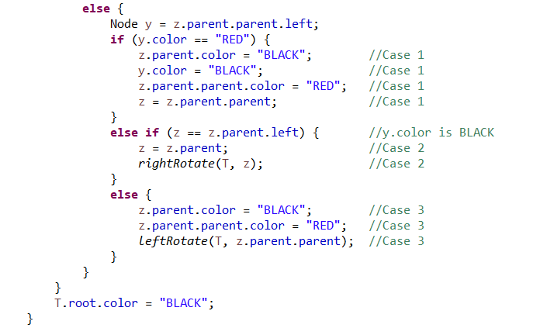

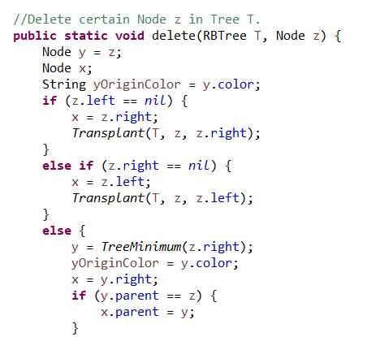

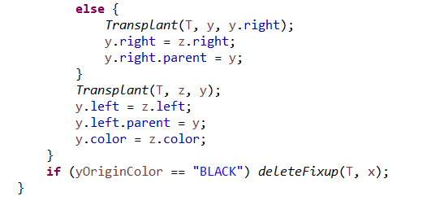

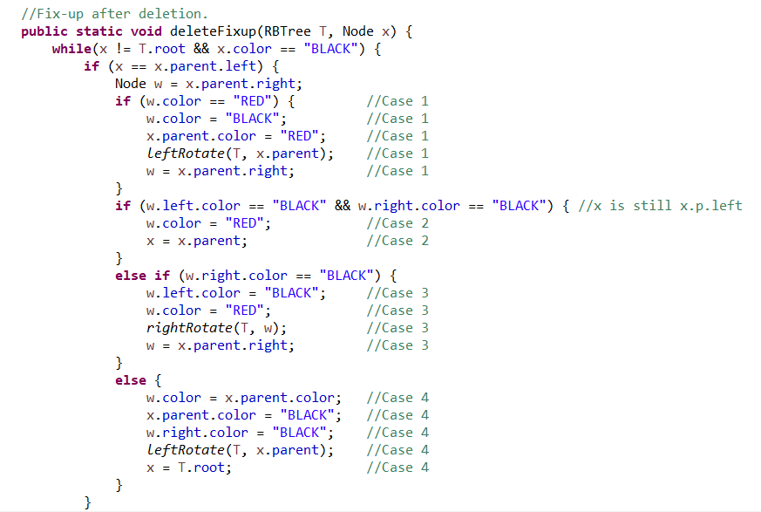

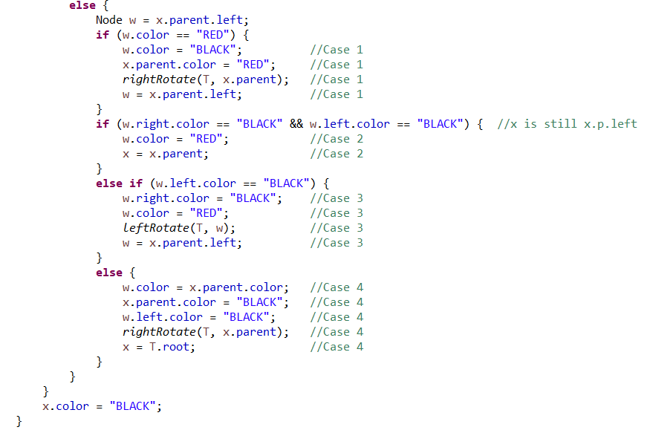

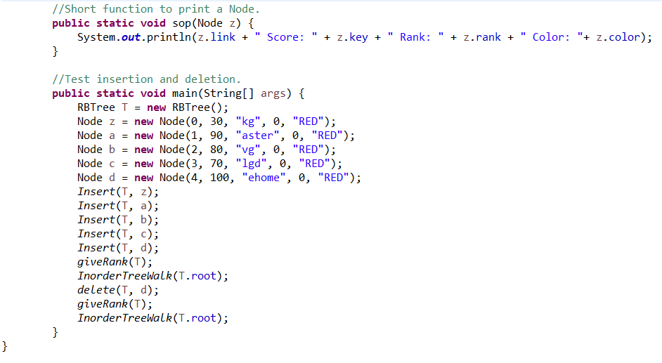

Class Grader is the executive class of the entire programming. In this class I collect 30 URLs from the web crawler, analyze and put them into the Binary Search Tree. In the main method we can print all 30 URLs and their index, total score, page rank and color. Moreover, we can do insert and delete using the function in Class Red Black Tree. Which will change the result of printing.

The screen shots of this class are the following:

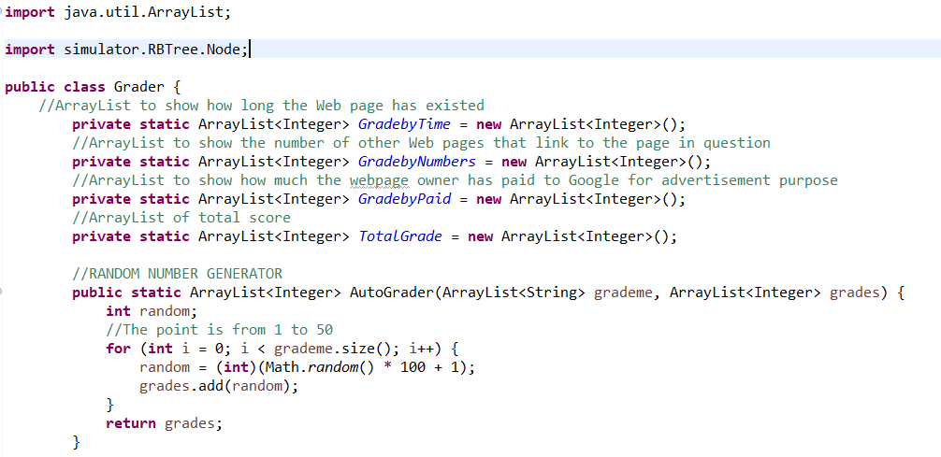

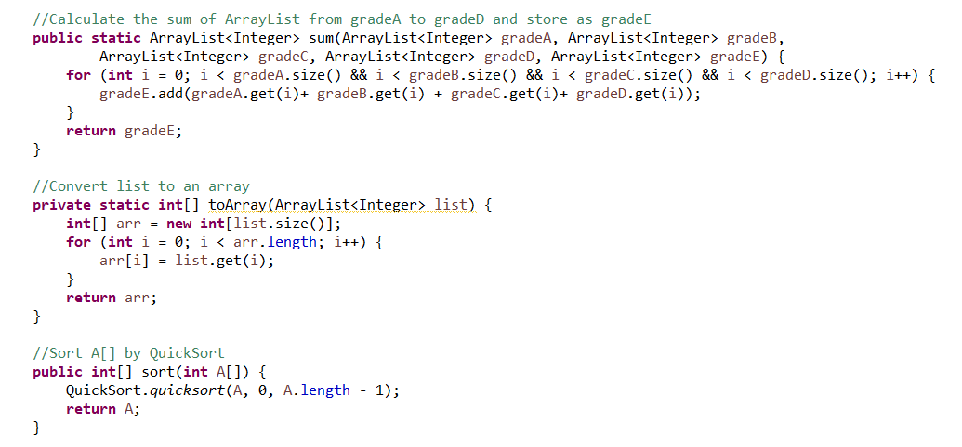

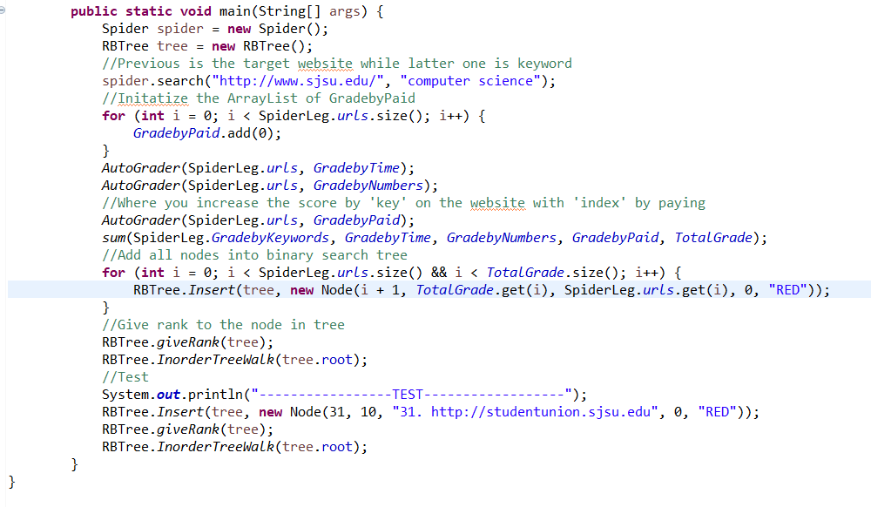

Here is the result of 30 URLs (sorting by total grade):

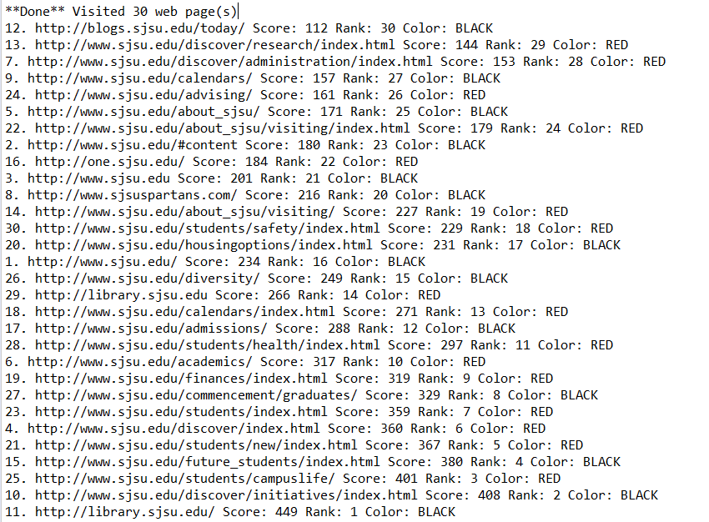

Test color by open source tool, every node is quite good, which prove the part of Insertion is well done.

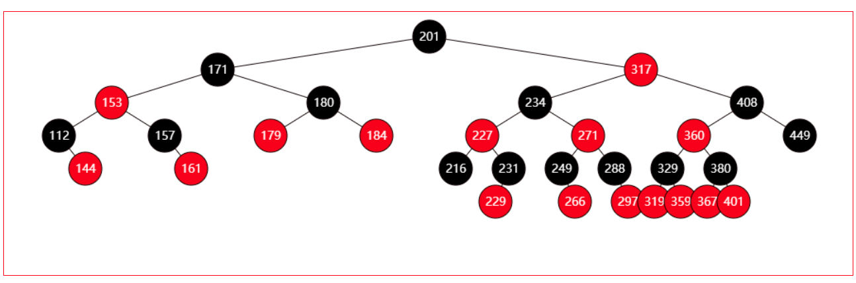

Functions:

Class QuickSort:

Function quicksort:

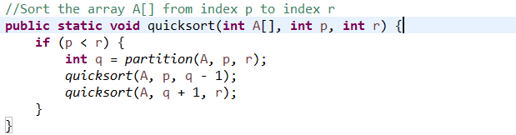

This function recursively sorts the two subarrays.

Function partition:

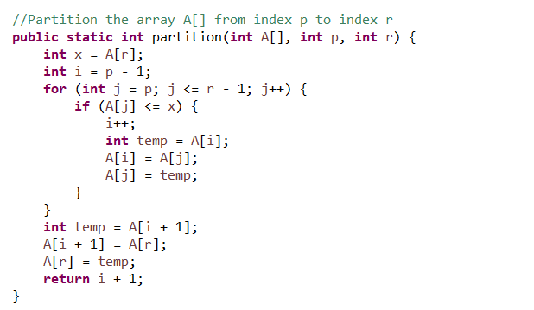

This function Partition the array into two subarrays around a pivot x such that elements in lower subarray≤ x ≤ elements in upper subarray.

Class Red Black Tree:

Class Node:

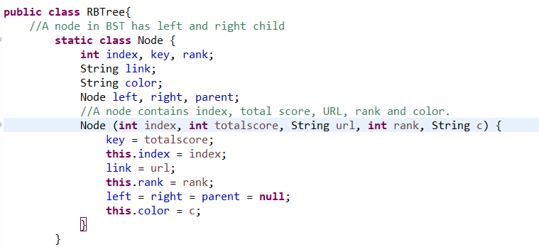

A node in RBTree must contain index, total score, URL, rank and color!

Class Node is based on RBTree.class so it is not public.

Constructor:

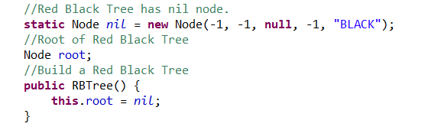

RB Tree has nil node and root. An empty tree’s root is nil.

Function search:

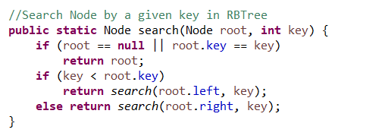

Search the certain node in the tree by its key.

Function In-order-Tree-Walk:

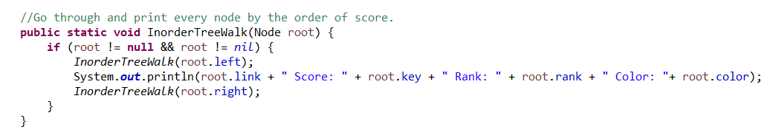

Go through the entire tree and print the detail of each node.

Function Iterative-Search:

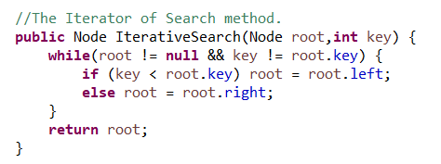

The Iterator of Search.

Function Tree-Minimum:

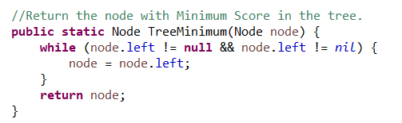

Return the node with Minimum Score in the tree under node.

Function Tree-Maximum:

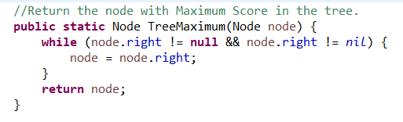

Return the node with Maximum Score in the tree under node.

Function Successor:

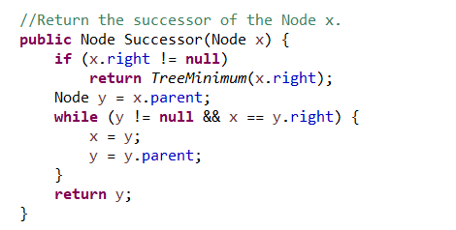

Return the successor of the Node x.

Function Transplant:

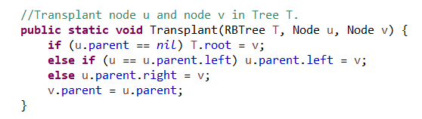

Transplant node u and node v in Tree T.

Function giveRank:

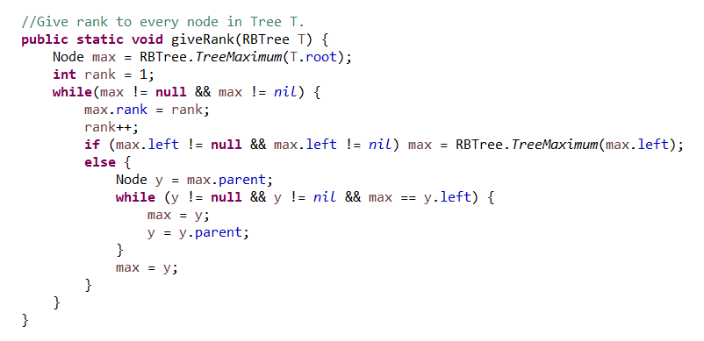

A self-designed function. Rank every node in Tree T.

Function left-Rotate:

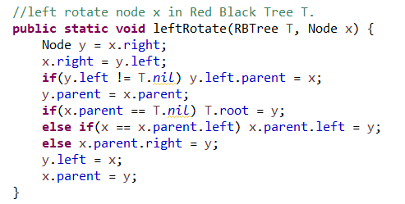

Left-Rotate node x in Tree T.

Function right-Rotate:

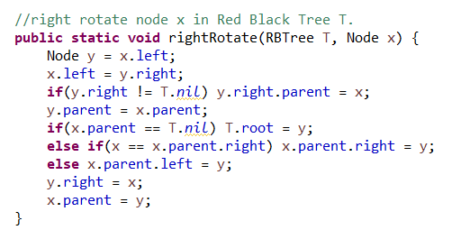

Right-Rotate node x in Tree T.

Function Insert:

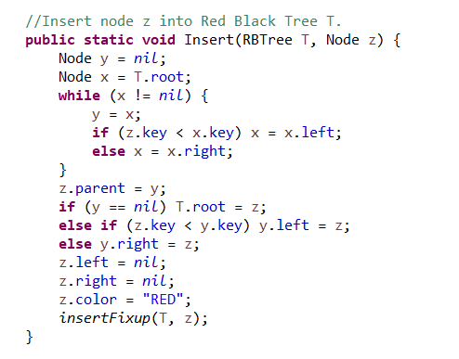

Insert node z into Tree T.

Function insert-Fix-up:

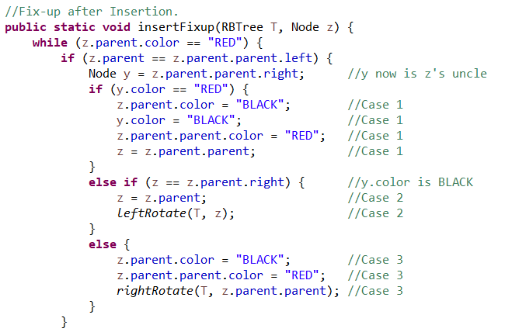

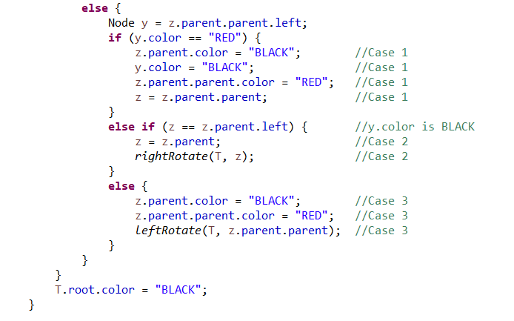

Fix-up after Insertion. It contains 3 cases.

The Deemo of Insertion:

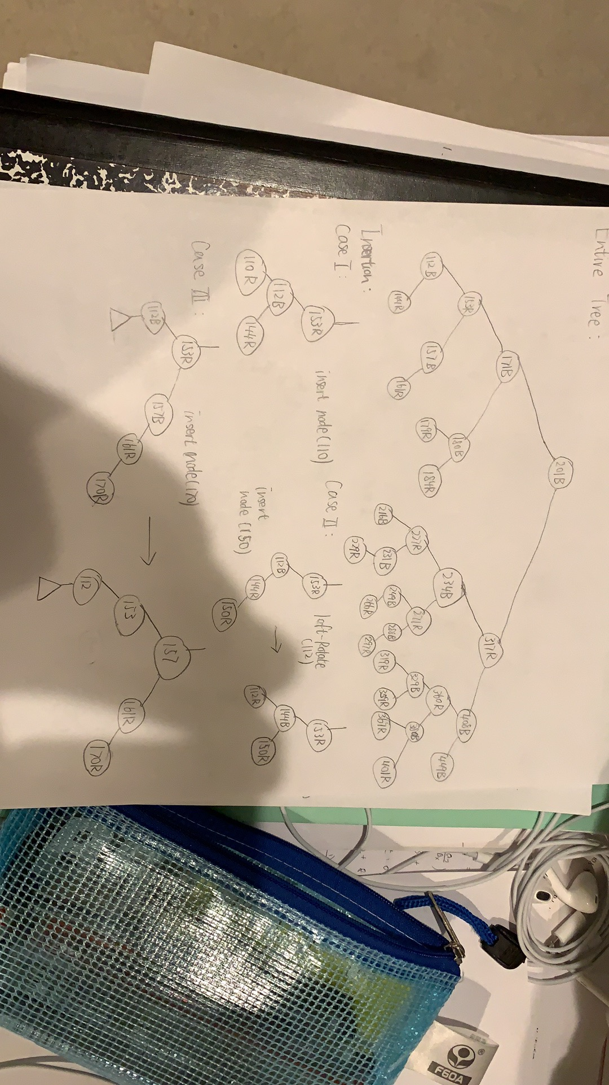

Function delete:

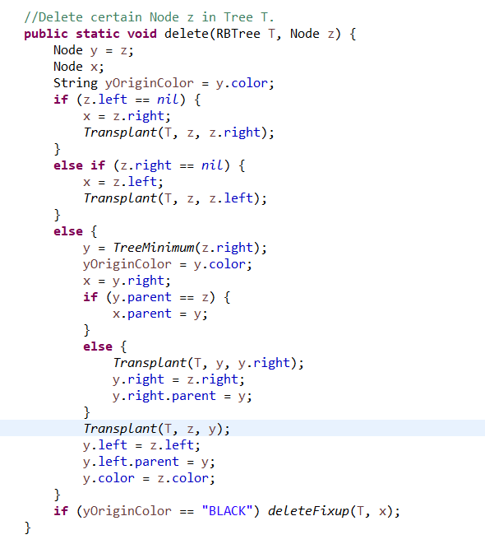

Delete certain Node z in Tree T.

Function delete-Fix-up:

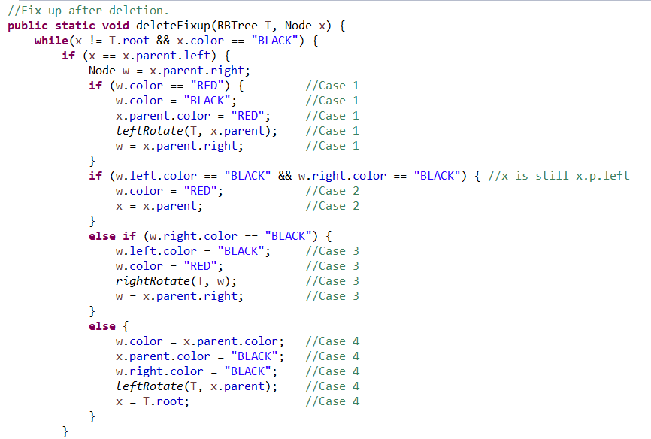

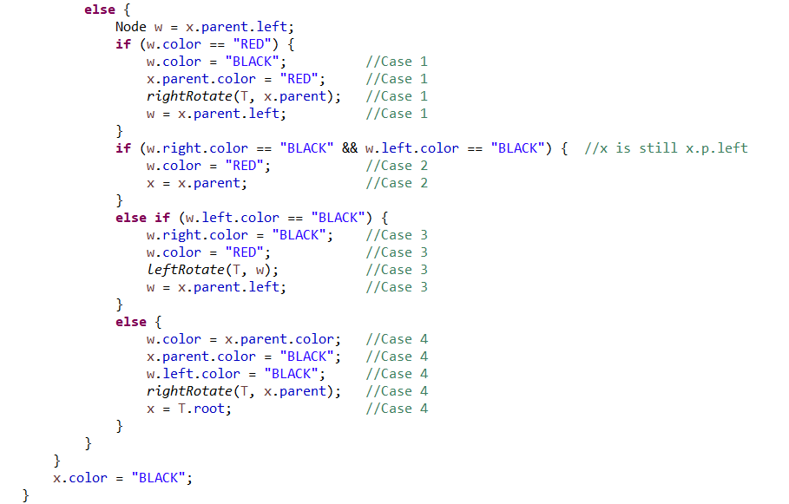

Fix-up after deletion. This function contains 4 cases.

Deemo of deletion:

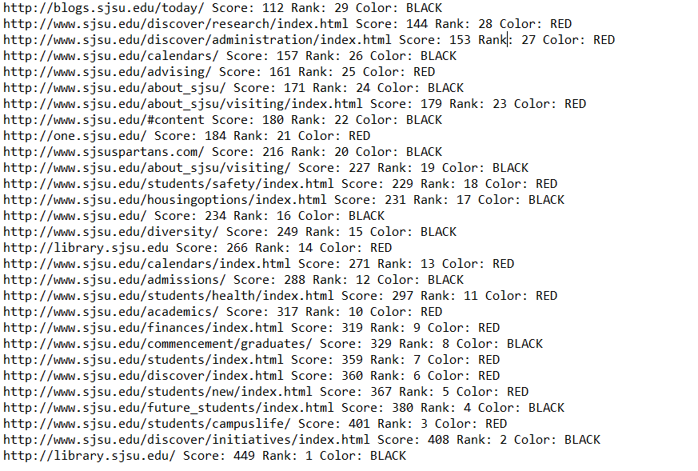

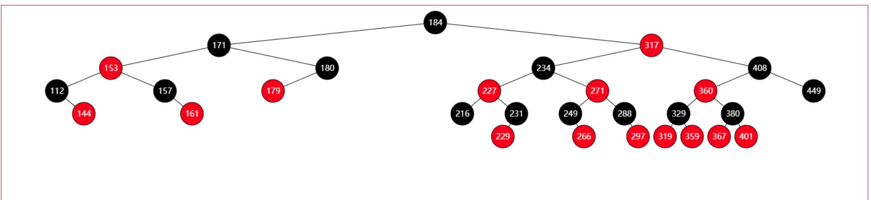

Function sop:

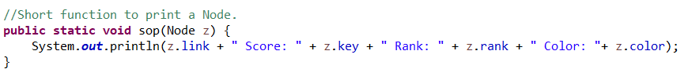

Print all details of a certain node.

Class Grader:

Function AutoGrader:

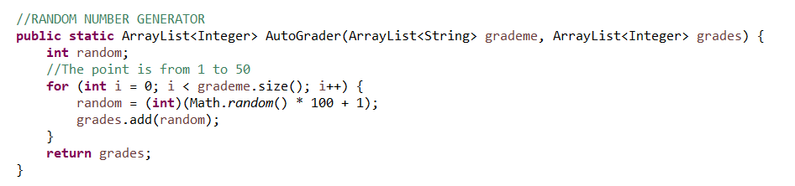

Random number generator. Give a random score for every URL in the given array-list.

Function sum:

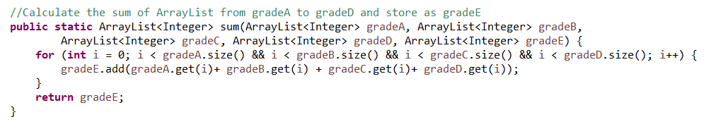

Calculate the sum of Array-List from grade-A to grade-D and store as grade-E.

Function sort:

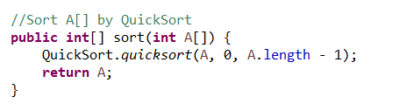

Sort A[] by Quick-Sort.

Part III. The procedure of how to unzip files, install application, and run/test codes:

First, unzip the zip and you will see a jar file called: PA3_Linjun_Cao.jar.

Then run the command and code in:

java jar- PA3_Linjun_Cao.jar

And the jar file will run itself.

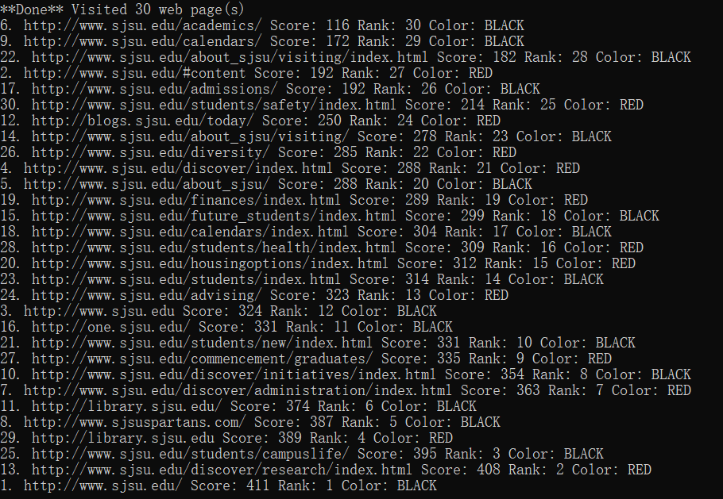

The result as showing.

Part IV. Problems encountered during the implementation:

When I implemented insert-fix-up function and delete-fin-up function, I met a problem. The pseudo code is not complete in the textbook. So, after I implement each function, I must test it in main method immediately. I created some nodes and put them into the tree then draw it. At the same time, I use open source tool to build a tree and compare the color of each node one by one between my tree and his tree. If any node is different, then I have to make some changes and test again and again. It takes a lot of time and I can’t find a better way to skip it.

Another question is because the total score is random. So, every time I run the program, the result is different. And there may have some node with same total score and it can’t be avoided.

Part V. Lessons Learned:

In this part I learn that when I faced a complicated problem, I can try to convert one case to another case. Then there is always a common case that can solve the problem.

Another thing I learn is when I met a challenge in coding, I can use pen to draw and simulate on paper. It is more clearly.